# **How To Guide: Kubernetes for Windows Flannel (Host-Gateway)**

## **Preface**

1. For Linux, more detailed documentation that uses similar commands to mine can be found [here](https://kubernetes.io/docs/setup/independent/install-kubeadm/).
2. You are recommended to use **Ubuntu 16.04** and **Windows Server 2019** [**Insider Builds**](https://blogs.windows.com/blog/tag/windows-insider-program/) for these instructions.
   1. Other Linux distributions where the Master was setup using “kubeadm” shouldalsowork. Just skip ahead to the “Launch Flannel” section in this guide after initialization.
      1. The exception this guide does **not** support ***as of time of writing*** is Ubuntu 18.04, as it requires modification of some steps and additional configuration for kube-dns.
   2. **Windows Server, version 1803** will work with these instructions as well.
3. “$” means a command was run as regular user whereas “#” denotes a command that was run as root.

## **(Optional, only required for Windows VMs) Prepare guest VM(s)**

Ensure MAC address spoofing/promiscuity mode and virtualization is enabled for the Windows container host VMs (guests). To achieve this, you should run the following as Administrator **on the VM host** server (example given for Hyper-V manager):

PS C:> Set-VMProcessor -VMName "<name>" -ExposeVirtualizationExtensions $true

PS C:> Get-VMNetworkAdapter -VMName "<name>" | Set-VMNetworkAdapter -MacAddressSpoofing On

All following commands in this how-to guide need to be executed on the container host machines (guests) directly.

# **K8s MASTER**

## **Linux Ubuntu**

To get to a root shell, you can use:

$ sudo –s

Make sure your machine is up to date:

# apt-get update && apt-get upgrade

## **Install Docker**

To get the most recent version, you can use [these instructions](https://docs.docker.com/install/linux/docker-ce/ubuntu/) for Docker installation.

## **Install K8s using kubeadm**

# curl -s <https://packages.cloud.google.com/apt/doc/apt-key.gpg> | apt-key add -

# cat <<EOF >/etc/apt/sources.list.d/kubernetes.list

deb http://apt.kubernetes.io/ kubernetes-xenial main

EOF

# apt-get update && apt-get install -y kubelet kubeadm kubectl

# nano /etc/fstab (*remove a line referencing 'swap.img'* , if it exists)

# swapoff -a

# kubeadm init --pod-network-cidr=10.244.0.0/16

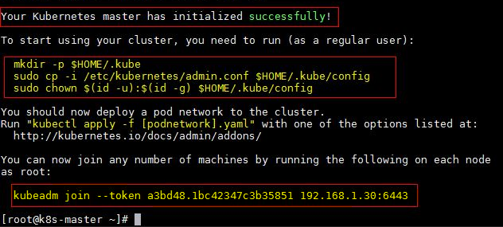

1. Note down kubeadm join command. We will need this later. For example: “kubeadm join <Master_IP>:6443 --token <some_token> --discovery-token-ca-cert-hash <some_hash>”
2. Note down pod network CIDR (also known as cluster CIDR) being used (e.g. 10.244.0.0/16)

Finally, to use kubectl, **as a regular user**, run:

$ mkdir -p $HOME/.kube

$ sudo cp -i /etc/kubernetes/admin.conf $HOME/.kube/config

$ sudo chown $(id -u):$(id -g) $HOME/.kube/config

## **Launch Flannel**

Enable passing bridged IPv4 traffic to iptables chains:

# sysctl net.bridge.bridge-nf-call-iptables=1

Option 1: Deploy my [example kube-flannel.yml](https://github.com/Microsoft/SDN/tree/master/Kubernetes/flannel/l2bridge/manifests/kube-flannel-example.yml) (v0.9.1)

Option 2: Edit it yourself, if a newer Flannel version greater than v0.9.1 has been released:

$ wget [https://raw.githubusercontent.com/coreos/flannel/**<version_here>**/Documentation/kube-flannel.yml](https://raw.githubusercontent.com/coreos/flannel/%3cv0.9.1/Documentation/kube-flannel.yml)

(Applies to option 2 only) Since the Flannel pods are only runnable on Linux, add a NodeSelector to kube-flannel.yml into kube-flannel-ds DaemonSet to only target Linux:

spec:

template:

spec:

nodeSelector:

beta.kubernetes.io/os: linux

Whichever option you chose, double-check that the type of network backend being used is set to “host-gw” and that the cluster CIDR (e.g. "10.244.0.0/16") conforms with what you put into the “kubeadm init” command when initializing the Master earlier.

net-conf.json: |

{

"Network": "10.244.0.0/16",

"Backend": {

"Type": "host-gw"

}

}

Launch Flannel using:

$ kubectl apply -f kube-flannel.yml

After a few minutes, you should see all the pods as running if the Flannel pod network was deployed.

$ kubectl get pods --all-namespaces

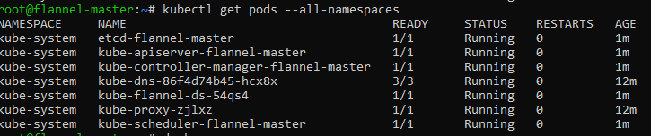

## **Edit Kube-Proxy DaemonSet**

Confirm that the update strategy of DaemonSet is set to [RollingUpdate](https://kubernetes.io/docs/tasks/manage-daemon/update-daemon-set/):

$ kubectl get ds/kube-proxy -o go-template='{{.spec.updateStrategy.type}}{{"\n"}}' --namespace=kube-system

Next, patch the DaemonSet by downloading [this nodeSelector](https://github.com/Microsoft/SDN/tree/master/Kubernetes/flannel/l2bridge/manifests/node-selector-patch.yml) and apply it to only target Linux:

$ kubectl patch ds/kube-proxy --patch "$(cat node-selector-patch.yml)" -n=kube-system

Once successful, you should see “Node Selectors” of DaemonSets set to **beta.kubernetes.io/os=linux**

$ kubectl get ds -n kube-system



Later in the “Join Windows Node to Master” section we will launch kube-proxy as a process using a Powershell script.

## **Collect Information to join Workers**

To summarize, the following information will be needed from the Kubernetes Master later:

* Kubeadm join command
  + For example, “kubeadm join <Master_IP>:6443 --token <some_token> --discovery-token-ca-cert-hash <some_hash>”
* Cluster CIDR defined during kubeadm init
  + For example, “10.244.0.0/16”
* Config file generated during kubeadm init
  + This can be found in one of either:
    - /etc/kubernetes/admin.conf
    - $HOME/.kube/config
* Service CIDR being used (can be found using kubectl cluster-info dump | grep -i service-cluster-ip-range)
  + For example, “10.96.0.0/12”
* Kube-DNS service VIP being used (can be found in “IP” field using kubectl describe svc/kube-dns -n kube-system)
  + For example, “10.96.0.10”

# **K8s WORKER**

## **Linux Ubuntu**

To get to a root shell, you can use:

$ sudo –s

Make sure your machine is up to date:

# apt-get update && apt-get upgrade

## **Install Docker**

To get the most recent version, you can use [these instructions](https://docs.docker.com/install/linux/docker-ce/ubuntu/) for Docker installation.

## **Install K8s, kubeadm**

# curl -s <https://packages.cloud.google.com/apt/doc/apt-key.gpg> | apt-key add -

# cat <<EOF >/etc/apt/sources.list.d/kubernetes.list

deb http://apt.kubernetes.io/ kubernetes-xenial main

EOF

# apt-get update && apt-get install -y kubelet kubeadm kubectl

# nano /etc/fstab (*remove a line referencing 'swap.img'* )

# swapoff -a

## **Distribute config file from Master**

**As regular user**, run:

$ mkdir -p $HOME/.kube

Copy (I used scp) config file ~/.kube/config from Master into $HOME/.kube/config on worker

$ sudo chown $(id -u):$(id -g) $HOME/.kube/config

## **Join Node to Master**

Enable passing bridged IPv4 traffic to iptables chains:

# sysctl net.bridge.bridge-nf-call-iptables=1

**As root**, run: kubeadm join command we noted down during Master setup. Eg:

# kubeadm join <Master_IP>:6443 --token <some_token> --discovery-token-ca-cert-hash <some_hash>

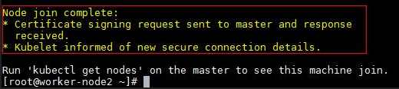

## **Windows Server**

## **Install Docker (requires reboot)**

PS C:> Install-Module -Name DockerMsftProvider -Repository PSGallery -Force

PS C:> Install-Package -Name Docker -ProviderName DockerMsftProvider

PS C:> Restart-Computer -Force

If after reboot you see the following error:

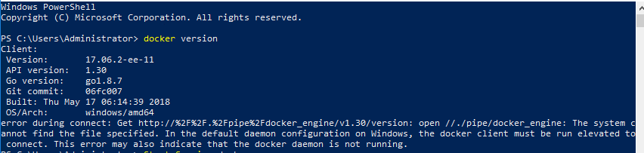

Then start the docker service:

PS C:> Start-Service docker

## **Prepare Infrastructure Image**

I recommend you pick an image and double-check that it works for your specific build. Otherwise, your pods may later be stuck in “ContainerCreating” status indefinitely. There are three steps to this: pulling the image, tagging it as microsoft/nanoserver:latest, and running it. For Windows Server 2019 images simply adjust the docker pull command below to match your specific insider build #:

* [microsoft/windowsservercore-insider](https://hub.docker.com/r/microsoft/windowsservercore-insider/)
* [microsoft/nanoserver-insider](https://hub.docker.com/r/microsoft/nanoserver-insider/)

For example, if you are on Windows Server 2019 build 17650, you can do the following:

Step 1: Pull the image for your build (either mcr.microsoft.com/nanoserver-insider:<your_build> or microsoft.com/nanoserver-insider:<your_build>)

PS C:> docker pull mcr.microsoft.com/nanoserver-insider:10.0.17650.1001

Step 2: Tag the Image as “microsoft/nanoserver:latest”

PS C:> docker tag mcr.microsoft.com/nanoserver-insider:10.0.17650.1001 microsoft/nanoserver:latest

Step 3: Double-check that the container runs on your computer:

PS C:> docker run microsoft/nanoserver:latest

You should see something like this:

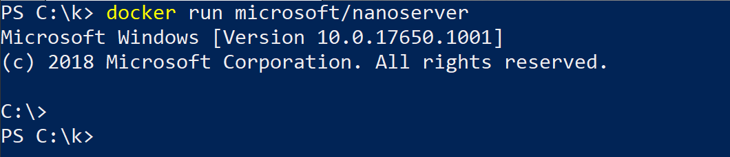

If you don’t please see: [matching container host version with container image](https://docs.microsoft.com/en-us/virtualization/windowscontainers/deploy-containers/version-compatibility#matching-container-host-version-with-container-image-versions).

For **Windows Server, version 1803** simply replace the docker pull command in step 1 with docker pull microsoft/nanoserver:1803 and make sure you tag your image as microsoft/nanoserver:latest in step 2.

## **Download Flannel Launch Scripts and K8s Binaries**

Create Kubernetes for Windows directory

PS C:> mkdir c:\k

Download the following **into c:\k**:

* [Kubernetes binaries](https://storage.googleapis.com/kubernetes-release/release/v1.10.2/kubernetes-node-windows-amd64.tar.gz) (kubelet.exe, kubectl.exe, kube-proxy.exe)
  + As of time of writing, latest stable release was v1.10.2. Check [K8s releases](https://github.com/kubernetes/kubernetes/releases/) and changelogs for updates.
* [Files in Flannel Windows (host-gw) directory](https://github.com/Microsoft/SDN/tree/master/Kubernetes/flannel/l2bridge)
  + **Ensure cluster CIDR (e.g. check “10.244.0.0/16”) is correct in:**
    - net-conf.json
* Copy config file $HOME/.kube/config from master into c:\k directory on Windows worker.

Once you are done, the **c:\k** directory should look as follows:

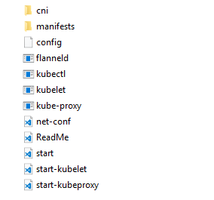

## **Join Windows Node to Master**

PS C:> cd c:\k

PS C:\k> .\start.ps1 -ManagementIP <Windows Node IP> -ClusterCIDR <Cluster CIDR> -ServiceCIDR <Service CIDR> -KubeDnsServiceIP <Kube-dns Service IP>

* This script will download additional files such as flanneld executable and the Dockerfile used to prepare the kubeletwin/pause image (*and run those for you*).
* Wait a couple minutes and this script will launch Flannel, kubelet, kube-proxy, and join the node to the Master.
  + Kubelet and kube-proxy will be visible in two separate powershell windows.
* You noted down the arguments <Cluster CIDR>, <Service CIDR>, <Kube-dns Service IP> from the Linux master in section **“Collect information to join Workers”**
* There may be a few seconds of network outage while the new pod network is being created.
* Afterwards, double check that all the values look correct in: cni/config/cni.conf.
  + *You can edit this file on-the-fly, and the configuration will apply automatically to any newly deployed Kubernetes resources.*

Now you can view the joined Windows node using kubectl get nodes or try scheduling an [example Windows service](https://github.com/Microsoft/SDN/tree/master/Kubernetes/flannel/l2bridge/manifests/simpleweb.yml) (don’t forget to make sure the container image pulled matches your host OS).